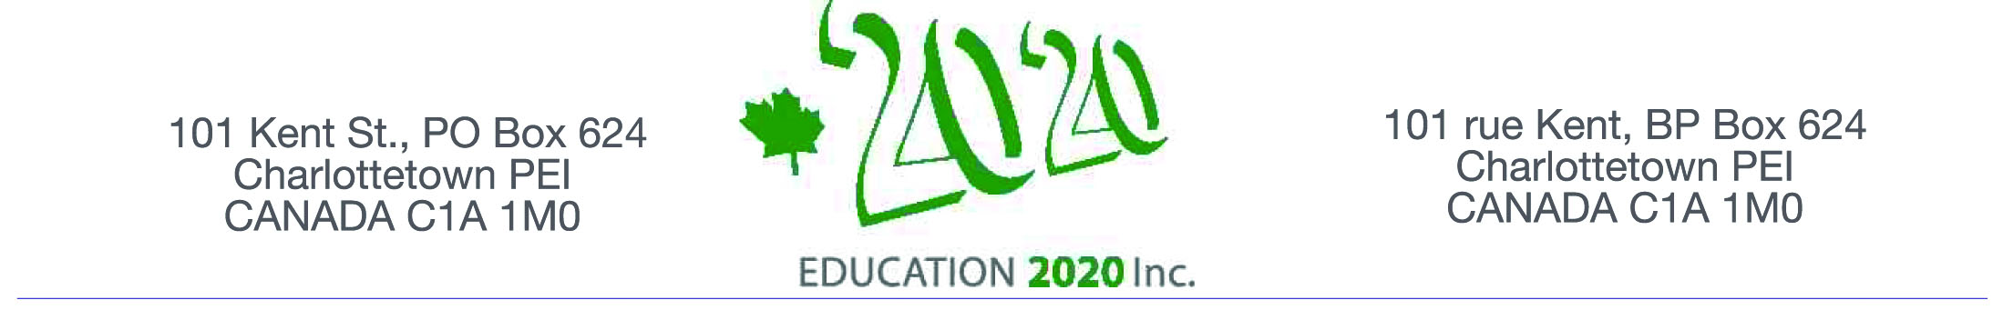

Excellence in Education Award – 2020

Numeracy Award

$2,500

AWARD

Education 20/20 Inc. is pleased to announce an Award in the amount of $2,500 in support of an innovative approach to helping Islanders improve their numeracy skills.

BACKGROUND

Numeracy refers to the application of math; it is described as “having the confidence and skill to use numbers and mathematical approaches in all aspects of life - at work, at home and beyond, as consumers, in managing our finances, helping our children learn, as patients making sense of health information, as citizens understanding the world about us.” A report by the PEI Department of Education on The Early Numeracy Intervention Program (ENIP) reports that numeracy “gives students the tools and the skills to solve problems logically, and to develop flexibility, independence of thought, self-efficacy, and the ability to persevere”; According to the Conference Board of Canada, “Over all, Canada earns a” C” grade on in adequate numeracy skills”

PROPOSAL

Applications should address each of the following:
- Problem or Issue
- Description
- Relevant research
- Location and dates
- Personnel
- Applicants may be invited for interview
- Final Report due by December 31, 2020

SUBMISSION
- Open to public institutions serving students at any level
- Applications may be submitted in print or electronic form; print should not exceed three single-spaced pages
- Applications close on February 28, 2020
- Selection will be based on documentation received.
- Final decisions will rest with Education 20/20 Inc.
- Applications may be sent to the address below or left at the office of the Community Foundation of Prince Edward Island, 119-121 Queen St. Charlottetown, PEI (Tel:902-892-3440)
Education 20/20 Inc.
101 Kent St., PO Box 624 / 101, rue Kent, B.P. 624
Charlottetown, PEI / Charlottetown (Î.-P.-É.) C1A 1M0 Canada
Tel./Tél. : 902-892-2060
Email/Courriel : pei@education2020.ca
URL : www.education2020.ca

